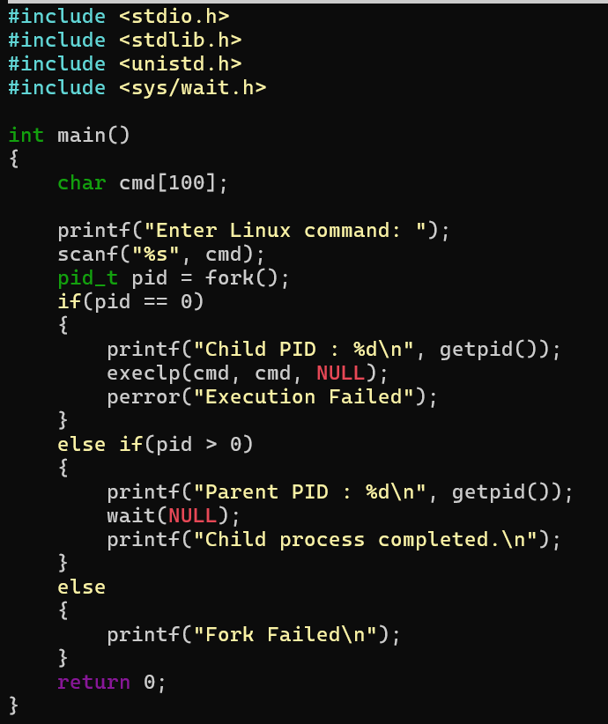
#include <stdio.h>
#include <stdlib.h>
#include <unistd.h>
#include <sys/wait.h>

int main()
{
char cmd[100];

printf("Enter Linux command: ");
scanf("%s", cmd);
pid_t pid = fork();
if(pid==0)
{
printf("Child PID : %d\n", getpid());
execlp(cmd, cmd, NULL);
perror("Execution Failed");
}
else if(pid > 0)
{
printf("Parent PID : %d\n", getpid());
wait(NULL);
printf("Child process completed. \n");
}
else
{
printf("Fork Failed\n");
}
return 0;
}

Uname:
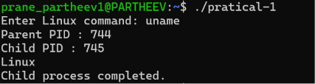
Lscpu:
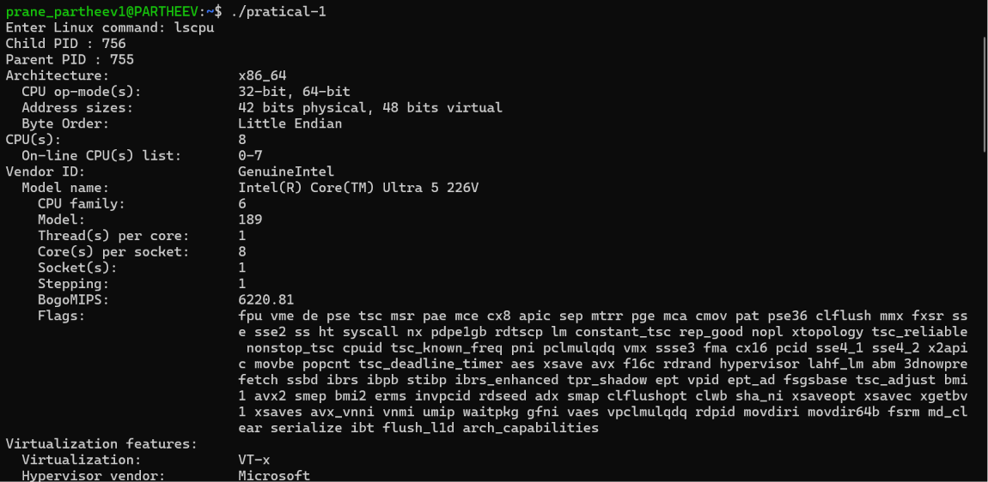

Lsblk:
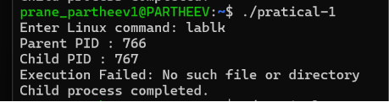
Ps:
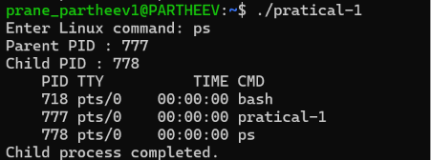
Top:
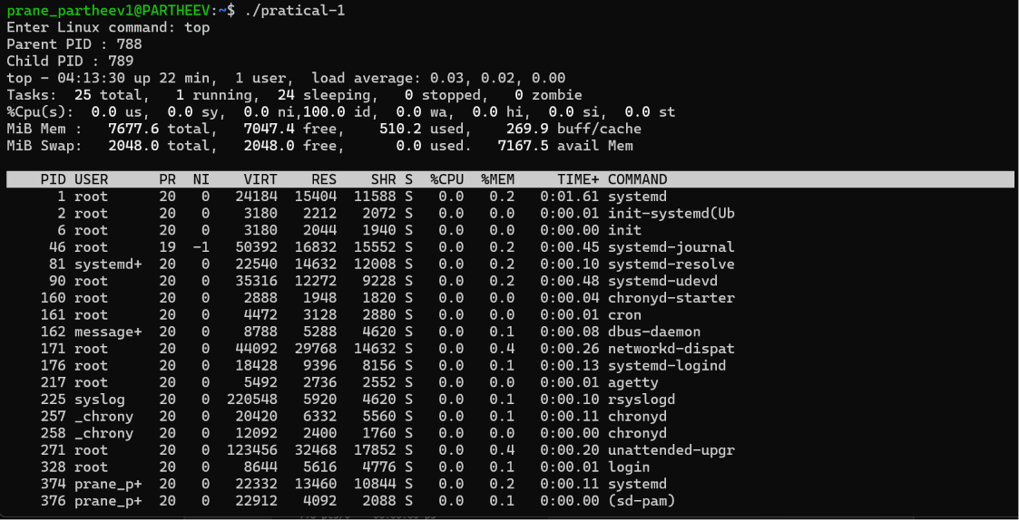

2. copying the contents from one file to another file

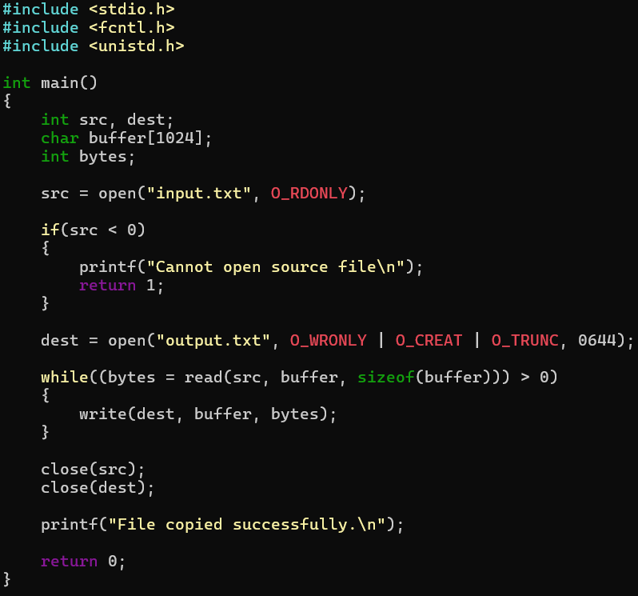
#include <stdio.h>
#include <fcntl.h>
#include <unistd.h>
int main()
{
int src, dest;
char buffer[1024];
int bytes;
src = open("input.txt", O_RDONLY);
if(src < 0)
{
printf("Cannot open source file\n");
return 1;
}
dest = open("output.txt", O_WRONLY | O_CREAT | O_TRUNC, 0644);
while((bytes = read(src, buffer, sizeof(buffer))) > 0)
{
write(dest, buffer, bytes);
}
close(src);
close(dest);
printf("File copied successfully. \n");
return 0;
}

